 | IQVIATM Work Instruction Handling Data Transfers
Document Number and Revision:
CS_WI_BS020 Revision 11
Document Owner:  Carrie Eason | Author(s):  Ian Sanderson

PURPOSE
  - To describe handling data transfers received or sent by Biostatistics and the use of project-specific Biostatistics Data Transfer Guidelines (DTG).

SCOPE
  - Applies to all projects for which IQVIA Biostatistics sends or receives data.

ROLES AND RESPONSIBILITIES
The following roles perform tasks described within this WI:

Role | Sections
Statistical Team Lead (STL) | 6.1, 6.2, 6.3, 6.4
Programming Team Lead (PTL) | 6.1, 6.2, 6.3
Biostatistics Project Team Member (BPTM) | 6.3
Quality Control Reviewer (QC) | 6.2, 6.3

The QC role can be any appropriate reviewer (statistician or programmer) who has the necessary QC knowledge.

DEFINITIONS
Not Applicable

MATERIAL AND EQUIPMENT
Not Applicable

PROCEDURE
This work instruction summarizes the following types of data transfers:
- Transfers received by Biostatistics
  - from IQVIA Data Management (DM)
  - from an external/internal vendor, customer, or other sources
- Transfers sent by Biostatistics to an external/internal vendor, customer, or other recipient

Note: if no test transfer is received then the first production transfer should be treated as a test transfer for the purposes of the requirements to be met prior to the test transfer.

Handling Data Transfers Received from IQVIA Data Management
This section describes the process related to data transfers provided to Biostatistics through IQVIA DM, including data that originated from an external vendor or other IQVIA function and is processed through IQVIA DM.

No: | Who: | Step: | When:
6.1.1 | STL/PTL | Reviews and authorizes the IQVIA DM-generated Data Transfer Guidelines (DTG) and reviews the IQVIA DM-generated Data Transfer Specifications or equivalent (if available) along with the test transfer in accordance with Statistical Review and Authorization of Data Management Plan Documents (CS_WI_BS008) and Data Transfer (CS_WI_DM0412). The annotated case report form (CRF) (e.g., Annotated Study Book, Annotated Trial Design) and/or Non-  CRF Data Guidelines should also be utilized to facilitate the test transfer review. | Upon receipt of guidelines/ specifications for review
6.1.2 | STL/PTL | Stores data in the \Data folder within the Biostatistics Directory Structure, under the sub folder: \CDM_Data or one of the other relevant sub folders. Limited team members are given write-access to this area of the project directory to prevent unintended modification. | Upon receipt of a data transfer from IQVIA DM
6.1.3 | STL/PTL | Reviews the test transfer to verify completeness according to Approaches to QC (CS_WI_BS015) and Approaches to QC: Appendix B - QC of Annotated Case Report Form (CRF)/File Creation Specifications (RAW)/Dataset Test Transfer (CS_OD_BS0230), cross-checking a summary of the content and associated metadata with the details on associated documentation.  Reviews subsequent transfers by verifying the following using a Biostatistics validated tool (e.g. DLEC):  - Completeness of the transfer, e.g. all expected datasets are included.  - The number of observations has increased or stayed the same in the new transfer.  - Any changes in variable/data formats e.g. character values/variables changed to numeric. Or variables contain completely different values, etc.  Note: The above list is not exhaustive and should be tailored to study specific needs and documented as such in the DTG.  Note: If the transfer is for an interim analysis, it is recommended to compare the transfer to Section 3 of the Interim Database Lock Plan  (CS_TP_DM0286) to ensure accuracy and completeness of the transfer.
6.1.4 | STL/PTL | - Confirms receipt of the data transfer via email. This message should indicate acceptance or rejection of the transfer following the approach described in Section 6.1.3.  - Tracks acceptance/ rejection of the data transfer using the purpose built tab in the latest Data Issues Log (CS_TP_BS014). | After review of the data transfer (applicable to both test and subsequent/ production transfers)

No: | Who: | Step: | When:
6.1.5 | STL/PTL | Records and communicates data issues to the IQVIA DM team by using the Data Issues Log (CS_TP_BS014).  Note: A single Data Issues Log (CS_TP_BS014) should be used for  communication and resolution of data issues throughout the life of the study. | When data issues are identified throughout the study

Handling Data Transfers Received from an External/Internal Vendor, Customer, or Other Sources
This section describes the process related to data transfers provided to Biostatistics from an external/internal vendor (non-IQVIA DM), customer, or other sources. Examples of such transfers include receiving data from an external data management vendor or IQVIA Pharmacokinetics.
No: | Who: | Step: | When:
6.2.1 | STL/PTL | Reviews any DTG provided by the external/internal vendor and determines whether it sufficiently describes the transfer procedure by comparing to the Biostatistics Data Transfer Guidelines (CS_TP_BS003). | Before test data transfer
6.2.2 | STL/PTL | If the provided DTG in the prior step is deemed insufficient or none are provided:  - Creates a Biostatistics DTG using the Biostatistics Data Transfer Guidelines (CS_TP_BS003)  - Initiates a discussion with the external/internal vendor if there are items that require further clarification to facilitate transfers | Before test data transfer
6.2.3 | QC | Reviews the Biostatistics DTG according to the following and completes a Reviewer Feedback Form (CS_FM_BS007) to document review:  - Approaches to QC (CS_WI_BS015)  - Biostatistics QC Plan (CS_TP_BS002)  - General and Trial Master File (TMF)-Specific Document Quality – Good Documentation Practices  (CS_WI_RM0284) | Before any production data transfer
6.2.4 | STL/PTL | - Provides the Biostatistics DTG for the external/internal vendor’s review  - Obtains authorization of the Biostatistics DTG from the external/internal vendor | Before any production data transfer
6.2.5 | STL/PTL | Stores data in the \Data folder within the Biostatistics Directory Structure, under the sub folder: \External or one of the other relevant sub folders and applies version control to the received data by placing it in a suitable subdirectory. | Upon receipt of a data transfer
6.2.6 | STL/PTL | - Performs a review of the data transfer received following the approach described in Section 6.1.3  - Determines whether to accept or reject the transfer  - Communicates acceptance or rejection to the sender in accordance with the DTG or other applicable documentation.

No: | Who: | Step: | When:
 |  | - Tracks acceptance/rejection of the data transfer using the purpose-built tab in the latest Data Issues Log (CS_TP_BS014).
6.2.7 | STL/PTL | Records and communicates data issues to the sender by using the Data Issues Log (CS_TP_BS014).  Note: A single Data Issues Log (CS_TP_BS014) should be used for communication and resolution of data issues throughout the life of the study. | When data issues are identified throughout the study

Handling Data Transfers Sent by Biostatistics
This section describes the process related to data transfers sent by Biostatistics to an

external/internal vendor, customer, or other recipient.

Biostatistics DTG (CS_TP_BS003) are expected for all situations in which data is sent via a vehicle of transfer (e.g., E-mail, FTP Server, Customer System) by Biostatistics. Examples include, but are not limited to:
    - Study Data Tabulation Model (SDTM) data transfers
    - Analysis Data Model (ADaM) data transfers
    - Non-Clinical Data Interchange Standards Consortium (CDISC) data transfers
    - Submission deliverable datasets that may, or may not, be accompanied by other submission documentation (e.g. Define files)
For transfers within Biostatistics that are conducted between a blinded and unblinded team, CS_TP_BS0214 (Biostatistics Blinded to Unblinded Team Handover Document) describes the transfer process and DTG are not required.

No: | Who: | Step: | When:
6.3.1 | STL/PTL | Creates a Biostatistics DTG using the Biostatistics Data Transfer Guidelines (CS_TP_BS003) and following conventions in General and Trial Master File (TMF)-Specific Document Quality – Good Documentation Practices (CS_WI_RM0284).  Note: When possible, it is recommended to discuss the transfer process with the recipient prior to or during the creation of the DTG. | Prior to delivery of the data transfer
6.3.2 | QC | Reviews the Biostatistics DTG according to:  - Approaches to QC (CS_WI_BS015)  - Approaches to QC: Appendix B - QC of Annotated Case Report Form (CRF)/File Creation Specifications (RAW)/Dataset Test Transfer (CS_OD_BS0230)  - Biostatistics QC Plan (CS_TP_BS002)  - General and Trial Master File (TMF)-Specific Document Quality – Good Documentation Practices (CS_WI_RM0284)

No: | Who: | Step: | When:
 |  | Completes a Reviewer Feedback Form (CS_FM_BS007) to document review.
6.3.3 | STL/PTL | Provides the Biostatistics DTG to the recipient to communicate the planned structure, content, and other delivery details.
6.3.4 | STL/PTL | Obtains authorization of the Biostatistics DTG.
6.3.5 | STL/PTL | - Updates the Biostatistics DTG when a change is made to the transfer process.  - Documents changes to new versions of the Biostatistics DTG in the modification history section  - Obtains authorization of the updated Biostatistics DTG. | During the study for any changes to the transfer process
6.3.6 | PTL/ BPTM | If programming is required for preparing files for transfer:  - Creates SAS Transport files (.xpt) and/or compile/compress as indicated by the Biostatistics DTG.  - Adheres to current best practices in Good Programming Practices documentation available under the Biostatistics Tools (Documentation folder) in ELVIS.  - Stores the program and datasets in an appropriate area within the Biostatistics Directory Structure. | When preparing files for transfer
6.3.7 | QC | - Confirms transfer has been prepared in accordance with the Biostatistics DTG, contains the expected files, and verifies accurate and successful copy of the correct data.  - Documents completion of review in the Reviewer Feedback Form (CS_FM_BS007).  Note: Review of the transfer must be completed by any team  member other than the original creator. It is recommended the STL or PTL should be either the creator or reviewer.
6.3.8 | STL/PTL | Sends the data transfer using secure file transfer methods (e.g., sFTP Server, Customer System, etc.) and in accordance with the Biostatistics DTG.  However, if sending an external data transfer via email:  - Clinical trial data is categorized as Level 3 – Restricted data, which means the data must by encrypted if shared via email (password protection of email attachments alone is not sufficient).  - Encrypts the email by following the instructions provided by Information Security in Encrypting An Email In Office 365.  - Password protects email attachments without exception. See IT Security Network/Resource Password Policy (CS_WI_IT207) for further guidance on password complexity requirements.  - Opens the attachment prior to sending and verifies it is the correct deliverable.  - Do not use the same email distribution list to send the password as was used for the transfer.  - Sends the password to exactly one person within the recipient organization using a new email chain. Asks that person to | Throughout the study when transferring data

No: | Who: | Step: | When:
distribute the password as needed within the recipient organization.
- Sends the password to IQVIA staff copied on the transfer in a new, separate email chain.

Requests acceptance/confirmation of successful transfer from the Sponsor/recipient.

Documentation
Study Team Members involved in the creation of the Biostatistcs DTG and transfer of data must store the electronic files and the guidelines according to the Biostatistics Directory Structure and in the eTMF as appropriate.

No: | Who: | Step: | When:
6.4.1 | STL | Files documentation in the relevant folder(s) based on the TMF platform used. The following documentation should be filed:  - All final authorized versions of the Biostatistics DTG (CS_TP_BS003).  - Tracking Document for Derived Datasets and Statistical Outputs (CS_TP_BS011)  - Reviewer Feedback Form (CS_FM_BS007)  - Data Issues Log (CS_TP_BS014)  Note: See Trial Master File (TMF) (CS_OP_TMF0007) and Management and Filing of Biostatistics Deliveries and Documentation (CS_WI_BS0237) for further guidance. | Within 30 days of finalization or on receipt

- SUPPORTING DOCUMENTATION
DOCUMENT NUMBER | TITLE
ESOP References
7.1 CS_FM_BS007 | Reviewer Feedback Form
7.2 CS_OD_BS0230 | Approaches to QC: Appendix B - QC of Annotated Case Report Form (CRF)/File Creation Specifications (RAW)/Dataset Test Transfer
7.3 CS_OP_TMF0007 | Trial Master File (TMF)
7.4 CS_TP_BS002 | Biostatistics QC Plan
7.5 CS_TP_BS003 | Biostatistics Data Transfer Guidelines
7.6 CS_TP_BS011 | Tracking Document for Derived Datasets and Statistical Outputs
7.7 CS_TP_BS014 | Data Issues Log

DOCUMENT NUMBER | TITLE
7.8 CS_TP_BS0214 | Biostatistics Blinded to Unblinded Team Handover  Document
7.9 CS_TP_DM0286 | Interim Database Lock Plan
7.10 CS_WI_BS008 | Statistical Review and Authorization of Data Management Plan Documents
7.11 CS_WI_BS015 | Approaches to QC
7.12 CS_WI_BS0237 | Management and Filing of Biostatistics Deliveries and Documentation
7.13 CS_WI_DM0412 | Data Transfer
7.14 CS_WI_IT207 | IT Security Network/Resource Password Policy
7.15 CS_WI_RM0284 | General and Trial Master File (TMF)-Specific Document Quality – Good Documentation Practices
Other References
7.16 Biostatistics  General Guidelines | Biostatistics Directory Structure
7.17 Biostatistics  General Guidelines | Good Programming Practices
7.18 Information  Security General Guidelines | Encrypting An Email In Office 365

- SUPERSEDES
DOCUMENT NUMBER | TITLE | REVISION NUMBER
8.1 CS_WI_BS020 | Handling Data Transfers | 10

- MODIFICATION FROM PREVIOUS REVISION

CHANGE | SECTION REFERENCE | JUSTIFICATION
Updated role of Lead Statistical Programmer (LP) to Programming Team Lead (PTL) | 3.0, 6.1, 6.2, 6.3 | Consistency with other Biostatistics SOPs
Added note to clarify requirements if no test transfer received | 6.0 | To provide clarity on current process
Removed note referencing GPP for Storage of Data | 6.1.2 | To reflect latest applicable procedures and standards
Removed reference to PROC CONTENTS and added reference to DLEC tool | 6.1.3 | To provide clarity on current process
Clarified this step applies to both test transfers and subsequent production transfers | 6.1.4 | To provide clarity on current process
Removed requirement to add a new tab in Data Issues Log for each transfer (purpose-built tab already exists) | 6.1.4, 6.2.6 | To reflect latest applicable procedures and standards
Updated this step to occur before test transfer instead of before production transfer | 6.2.2 | To provide clarity on current process
Swapped the order of steps  6.2.5 and 6.2.6 | 6.2.5, 6.2.5 | To provide clarity on current process
Added reference to other submission documentation e.g. Define | 6.3 | To provide clarity on current process
Added reference to Approaches to QC: Appendix B  - QC of Annotated Case Report Form (CRF)/File Creation Specifications (RAW)/Dataset Test Transfer (CS_OD_BS0230) | 6.3.2 | To provide clarity on current process
Updated to document review in Reviewer Feedback Form (CS_FM_BS007) instead of Tracking Document for Derived Datasets and Statistical Outputs (CS_TP_BS011) | 6.3.7 | To provide clarity on current process

Added requirement for data encryption for Level 3 Restricted data | 6.3.8 | To reflect latest applicable procedures and standards
Added guidance for password complexity requirements | 6.3.8 | To provide clarity on current process
Added requirement to request acceptance/confirmation of transfer from sponsor | 6.3.8 | To provide clarity on current process
Added reference to Management and Filing of Biostatistics Deliveries and Documentation (CS_WI_BS0237) | 6.4.1 | To provide clarity on current process
Added reference to Management and Filing of Biostatistics Deliveries and Documentation (CS_WI_BS0237) and IT  Security Network/Resource Password Policy (CS_WI_IT207) | 7.0 | To reflect latest applicable procedures and standards

- APPENDICES

Appendix A: Data Transfer Workflow

Appendix A: Data Transfer Workflow
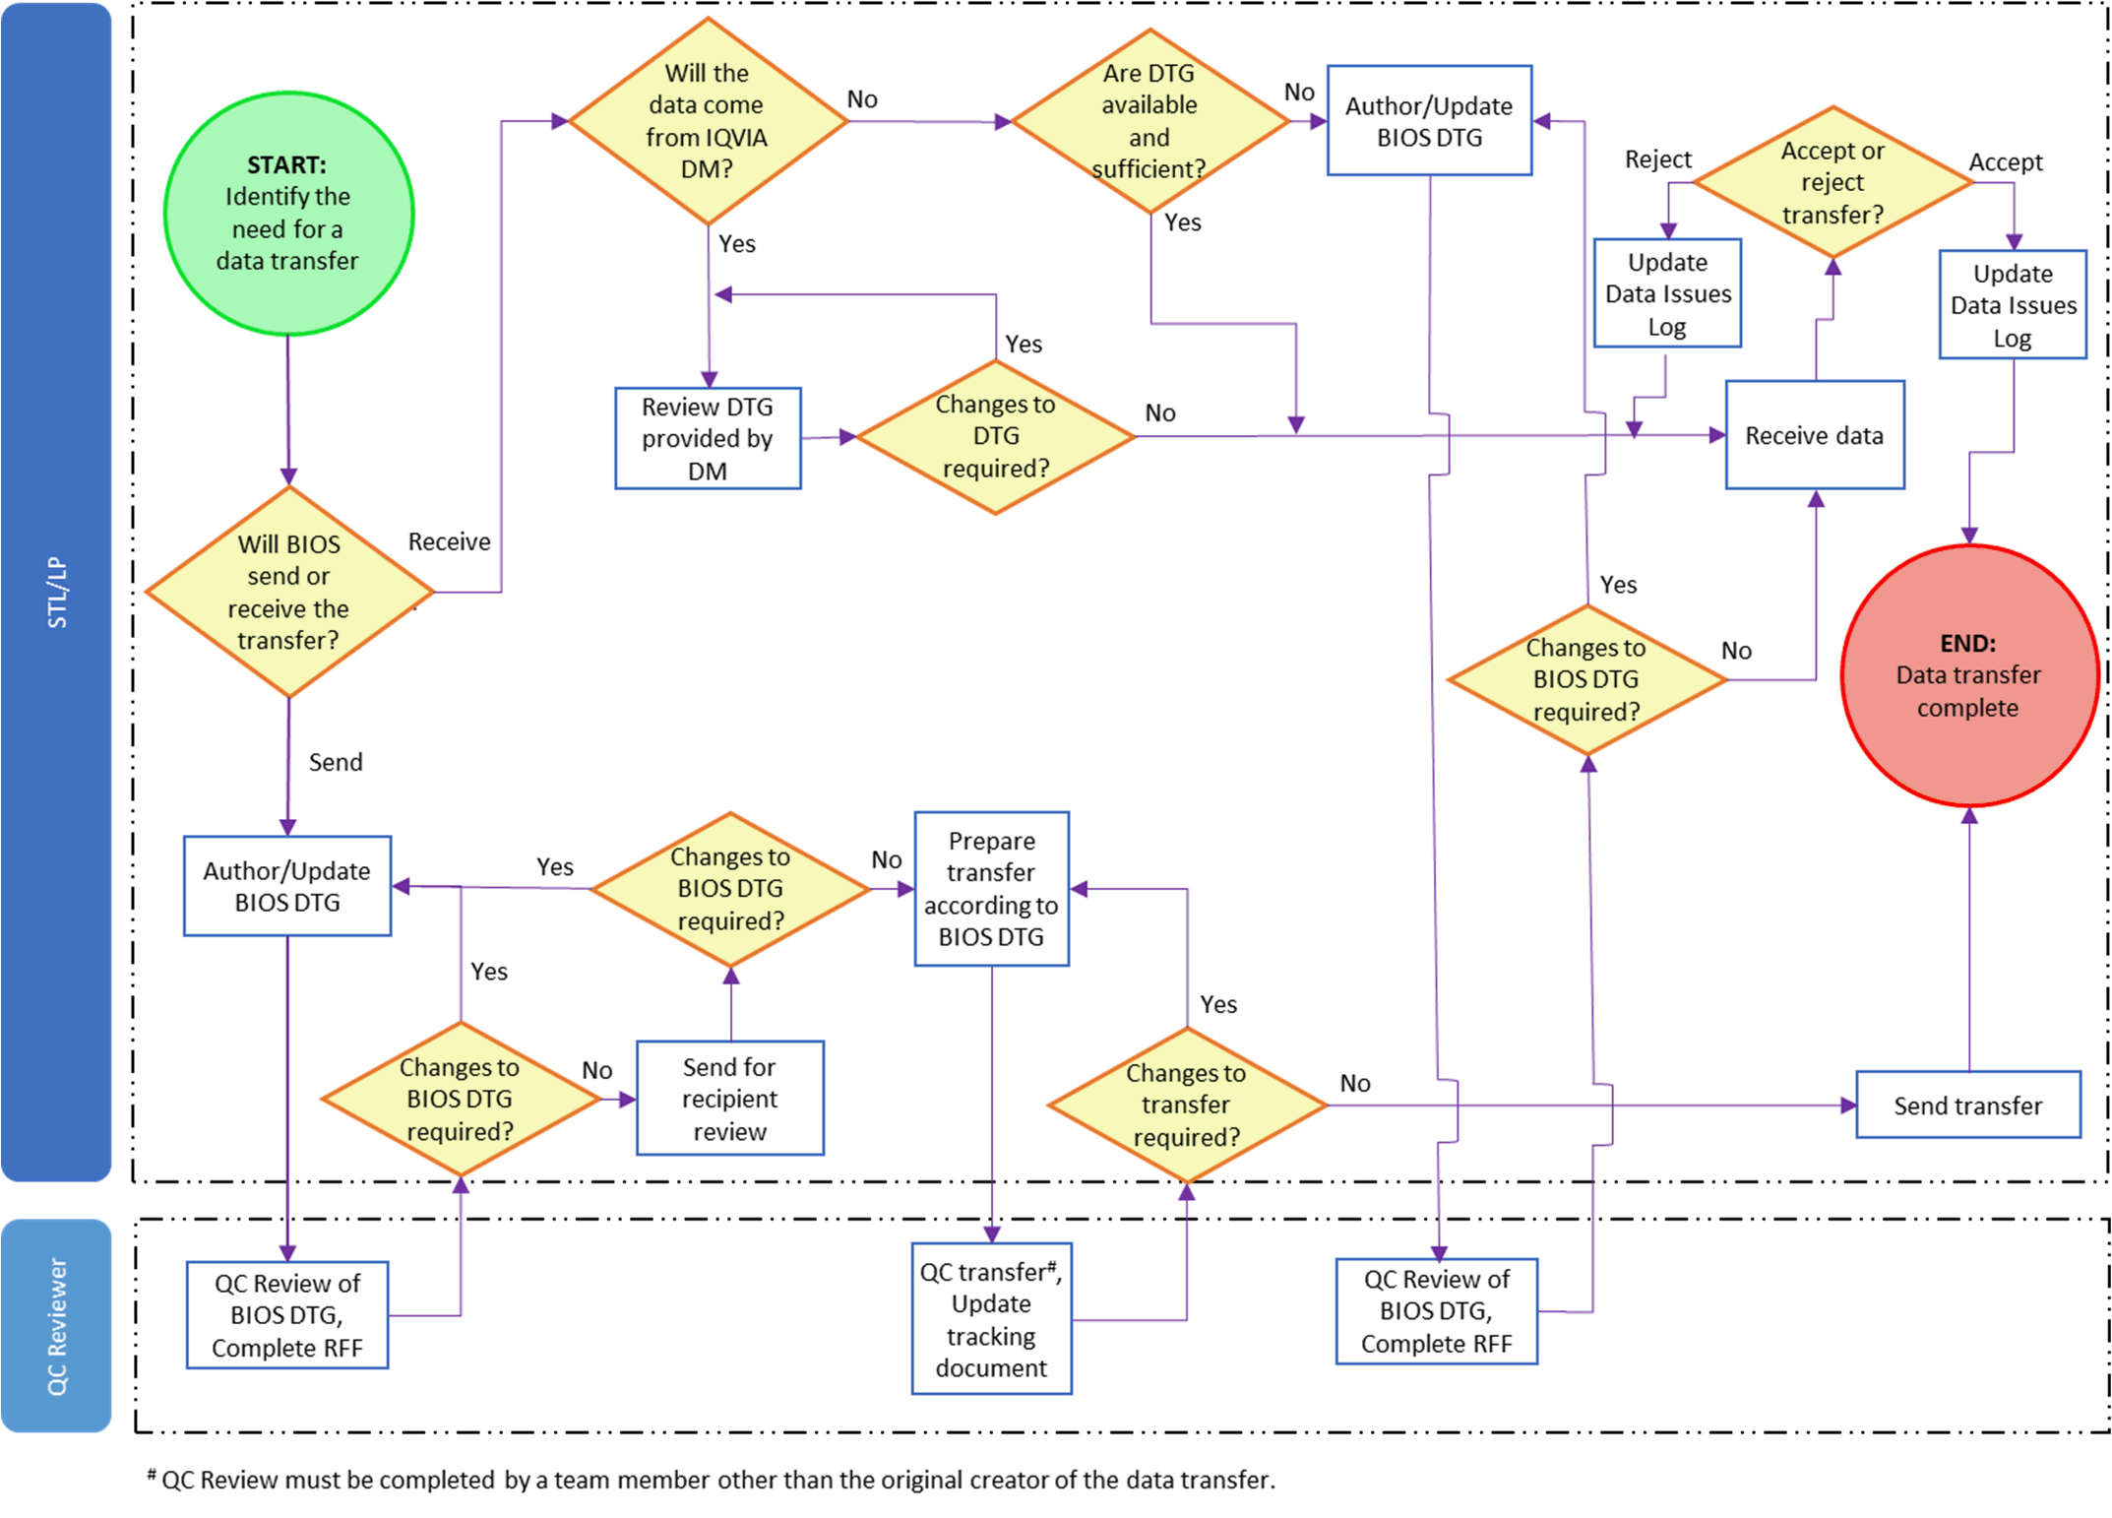

Page 12 of 12
Copyright © 2003, 2006, 2008, 2010, 2012, 2014, 2016, 2018, 2020, 2022 IQVIA. All rights reserved. The contents of this document are confidential and proprietary to IQVIA Holdings Inc. and its subsidiaries. Unauthorized use, disclosure or reproduction is strictly prohibited.

Standard Operating Procedure Approval Signature(s)
This is a representation of an electronic record that was signed electronically in Content Server.
This page is the manifestation of the electronic signature(s) used in compliance with the organization’s electronic signature policies and procedures
Refer to Signatories CV for Business Title.

UserName: Marcus, Ari (q774256) Title:
Date: Tuesday, 16 August 2022, 08:51 AM Eastern Daylight Time Meaning: Signing this Document Indicates My Approval
================================================

UserName: Bickford, Emma (q637065) Title:
Date: Wednesday, 17 August 2022, 09:45 AM Eastern Daylight Time Meaning: Signing this Document Indicates My Approval
================================================

UserName: Ranjan, Santosh (q723916) Title:
Date: Wednesday, 24 August 2022, 12:07 PM Eastern Daylight Time Meaning: Signing this Document Indicates My Approval
================================================

